**P5 – Test an object oriented application**

|  |  |  |  |  |  |
| --- | --- | --- | --- | --- | --- |
| **Test Number** | **Description** | **Expected Result** | **Actual Result** | **Pass or Fail?** | **Screenshot Reference** |
| **1** | Login Screen | The expected result of the login screen is for the user to log in to the part where he/she wants to calculate something. | The actual result is that both of them, username and password, is correct. | Pass | **Figure 1.1** |
| **2** | Produce correct calculations | The expected result of this is that it is supposed to add all the numbers that have been entered in the textboxes. | The expected result is that it adds all of the calculations correctly. | Pass | **Figure 1.2** |
| **3** | Button works | Checking if the button works. | The button calculated it and done as it has been told to do | Pass | **Figure 1.1** |
| **4** | Help and Support button | Checking if the button clicks to show the user if he or she is stuck | The button shows the form and it is a step-by-step guide. | Pass | **Figure 1.3** |
| **5** | Clear button | Does the clearing button clear all the textboxes? | Once the numbers had been typed in to, it cleared all of it. | Pass | **Figure 1.4** |
| **6** | Database | The expected result is for the database to be linked with the system, get information, and close. It has to insert it as well. | The actual result worked well. It opened it, closed it and got the information. | Pass | **Figure 1.5** |
| **7** | VAT | The expected result is for the overall cost to be added with the VAT | The actual result is that the VAT adds together the total cost with the VAT. | Pass | **Figure 1.6** |
| **8** | Quit Button | The expectation is that the calculation form closes. | It closed the application. | Pass | **Figure 1.7** |
| **9** | Validation | The expectation is that the program would detect anything that is not supposed to be entered. | If I enter the password wrong, a message would come up saying, “Username and Password do not match”. | Pass | **Figure 1.1** |

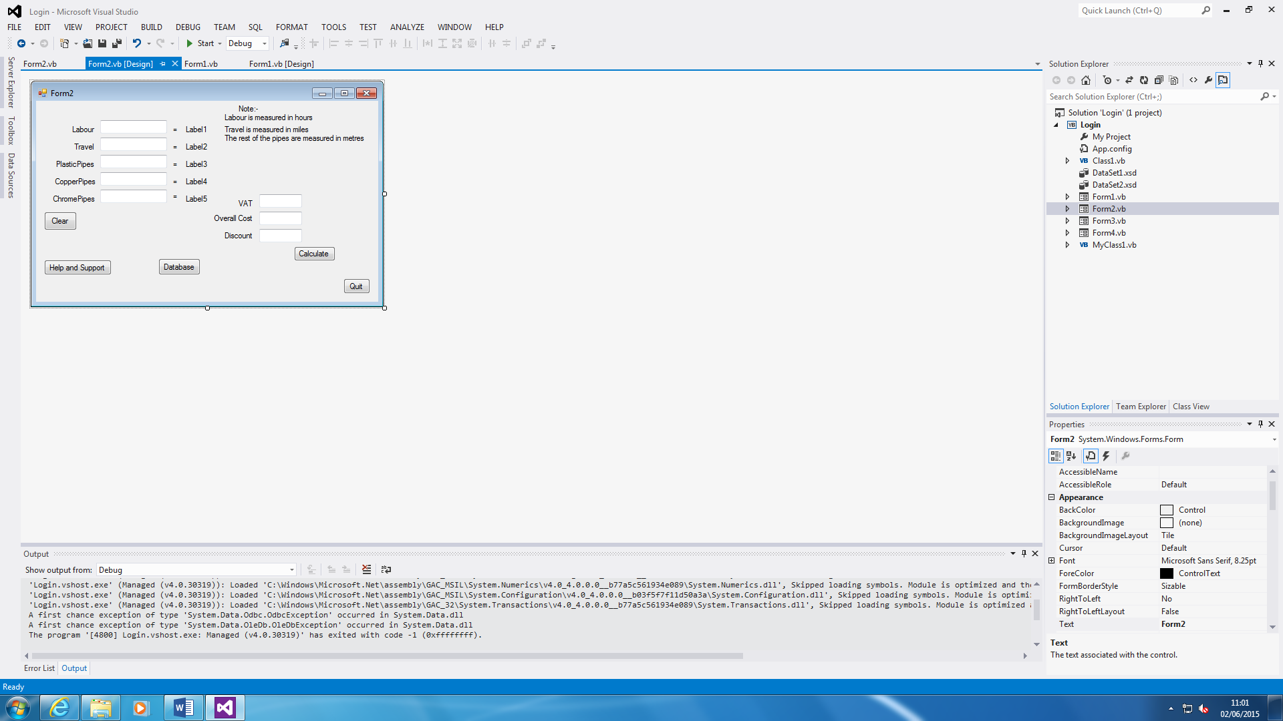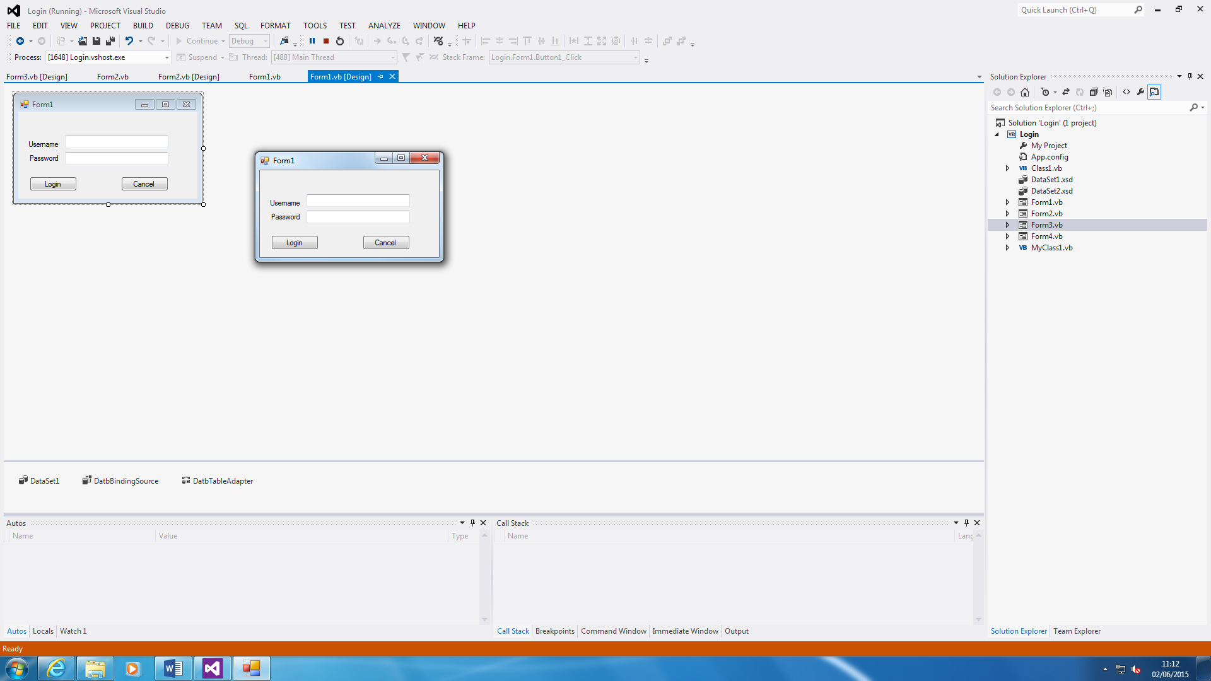 **Login Screen**

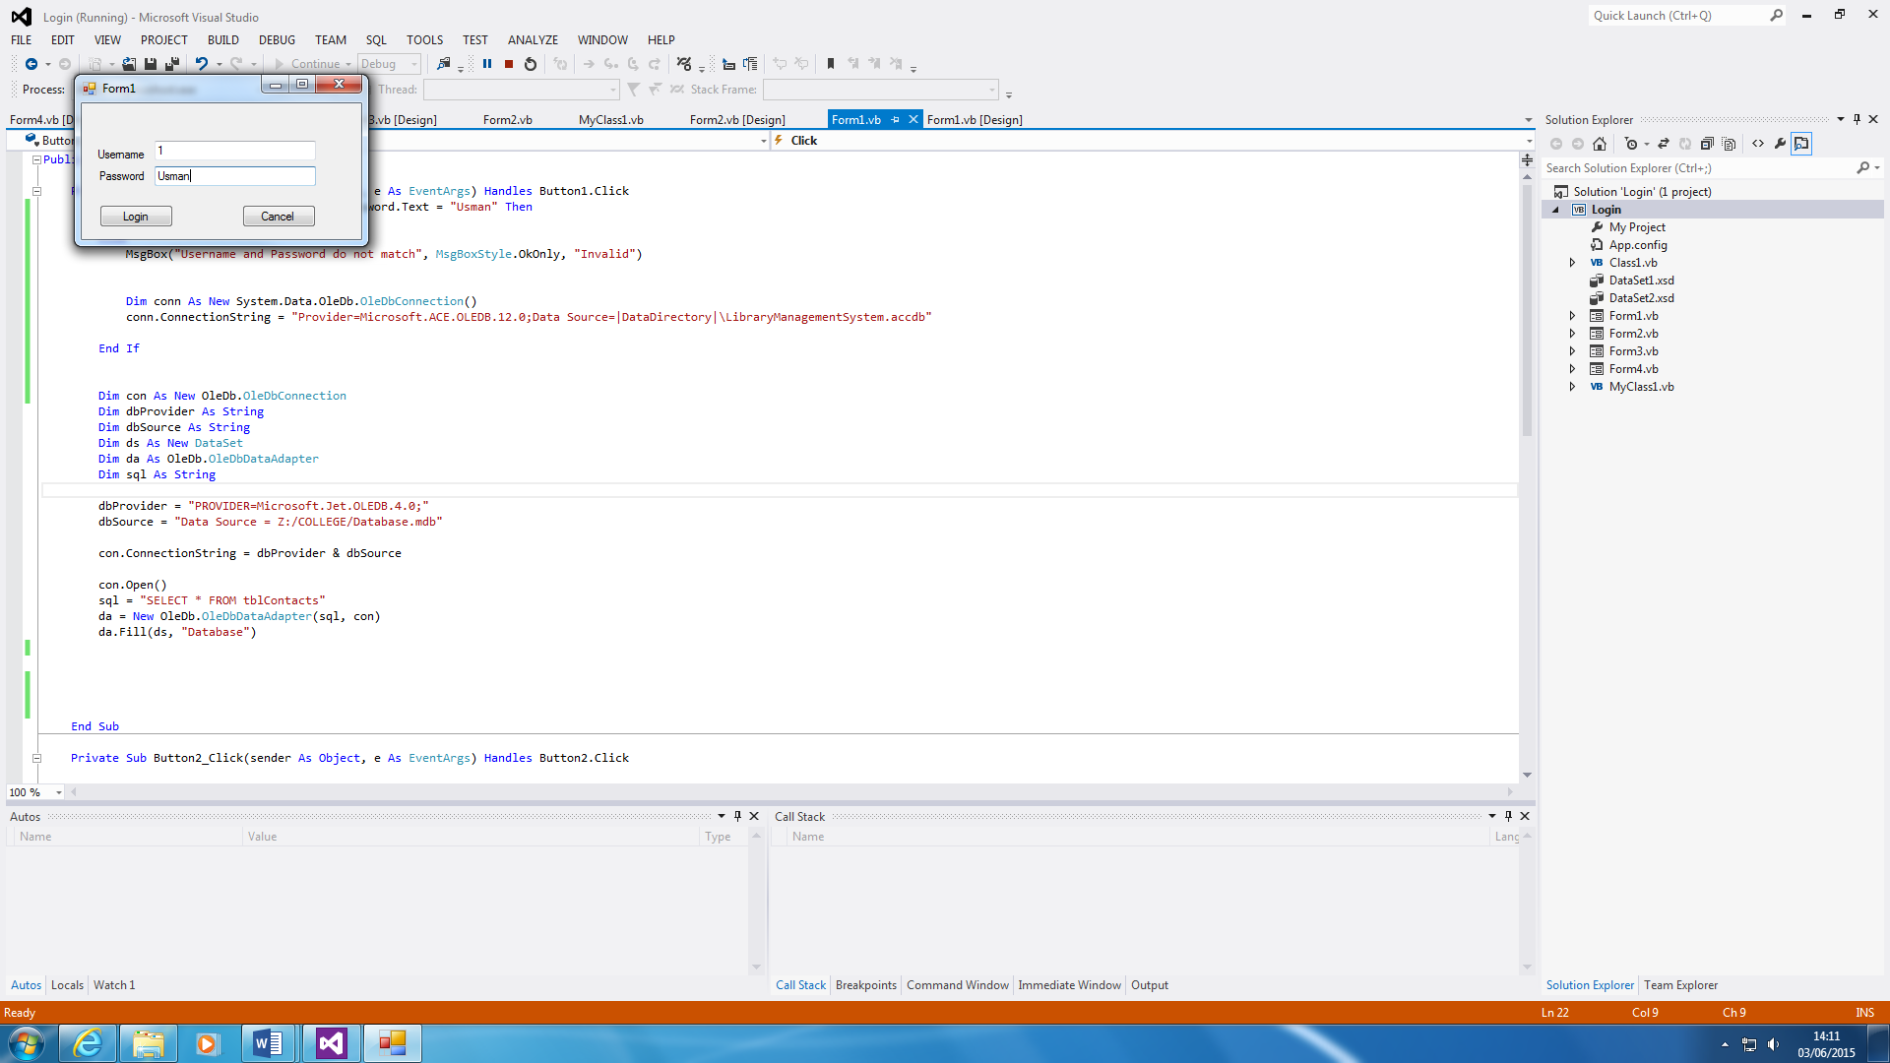

Figure 1.1

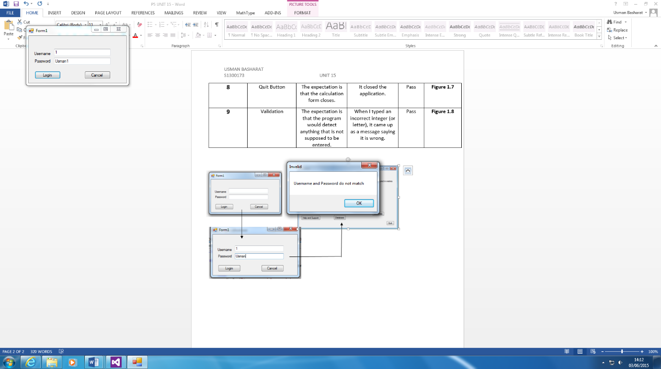

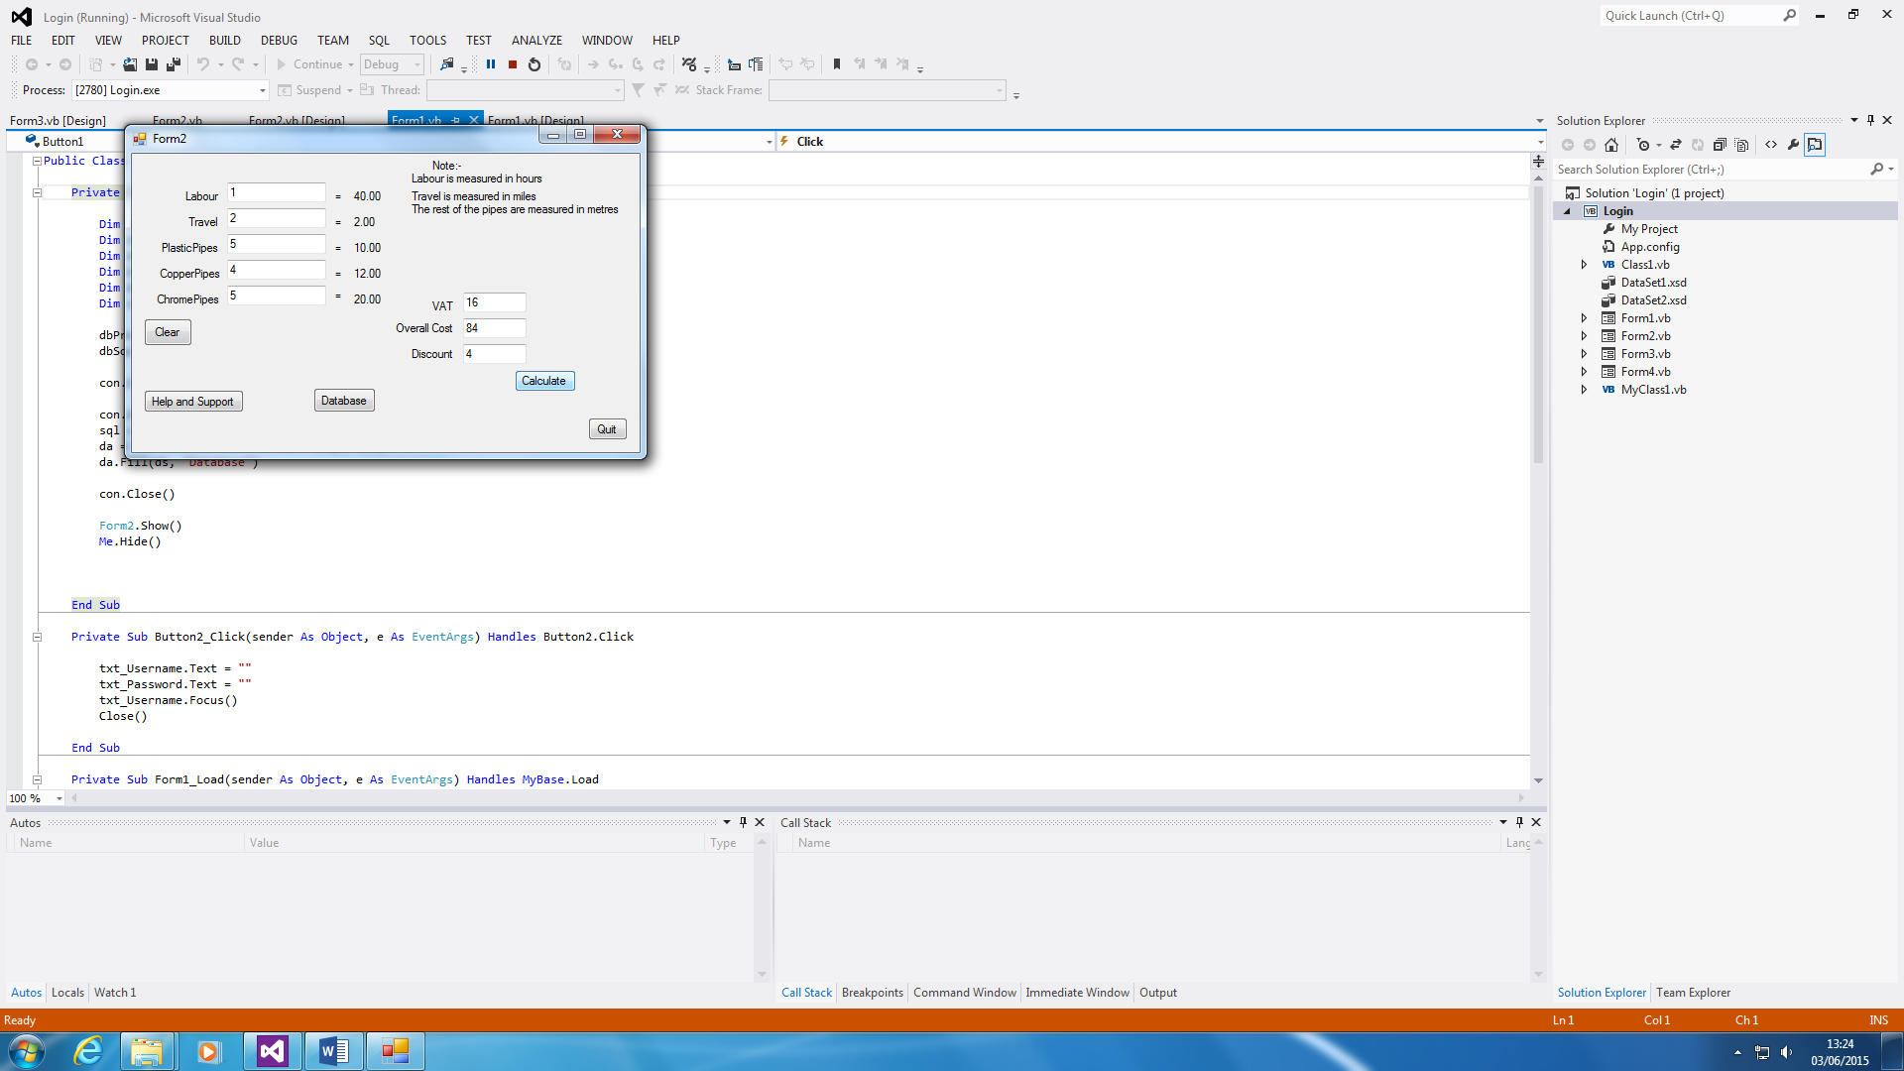**Calculations**

Figure 1.2

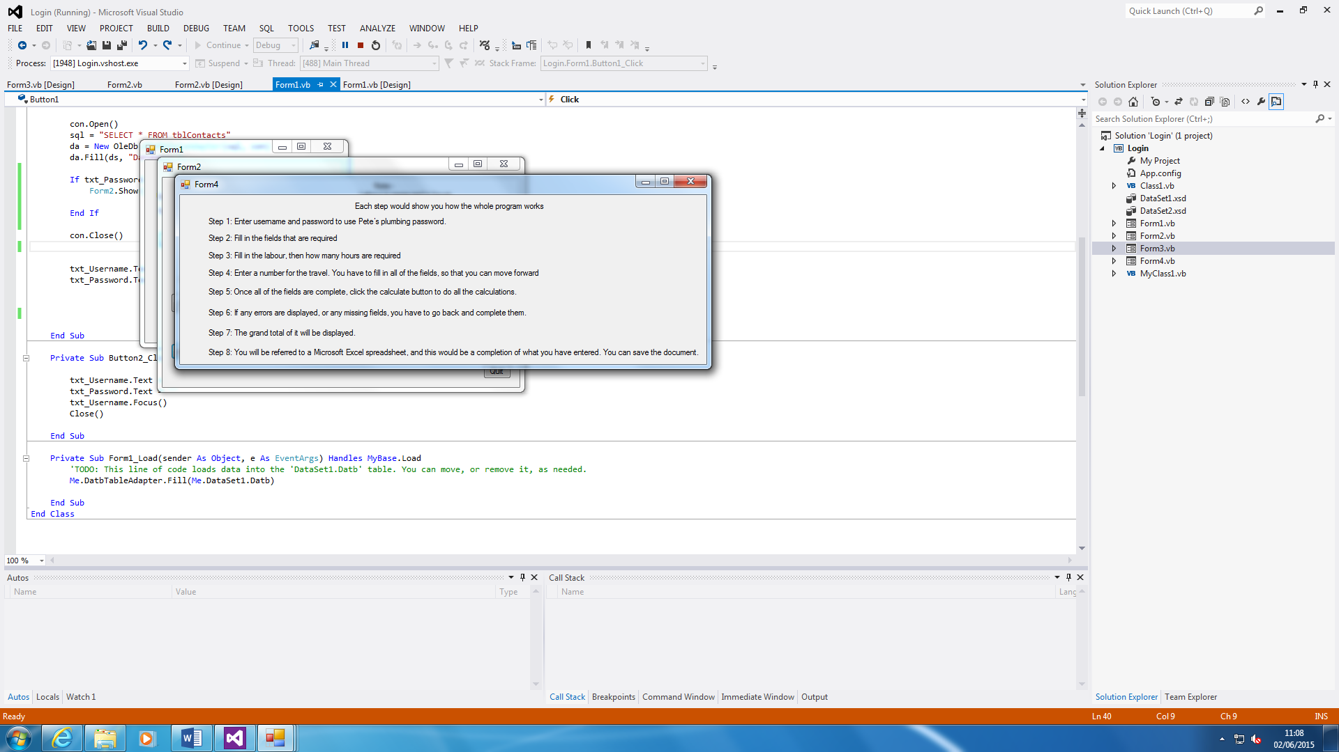**Help and Support**

Figure 1.3

**Clearing**

Figure 1.4



**Database**

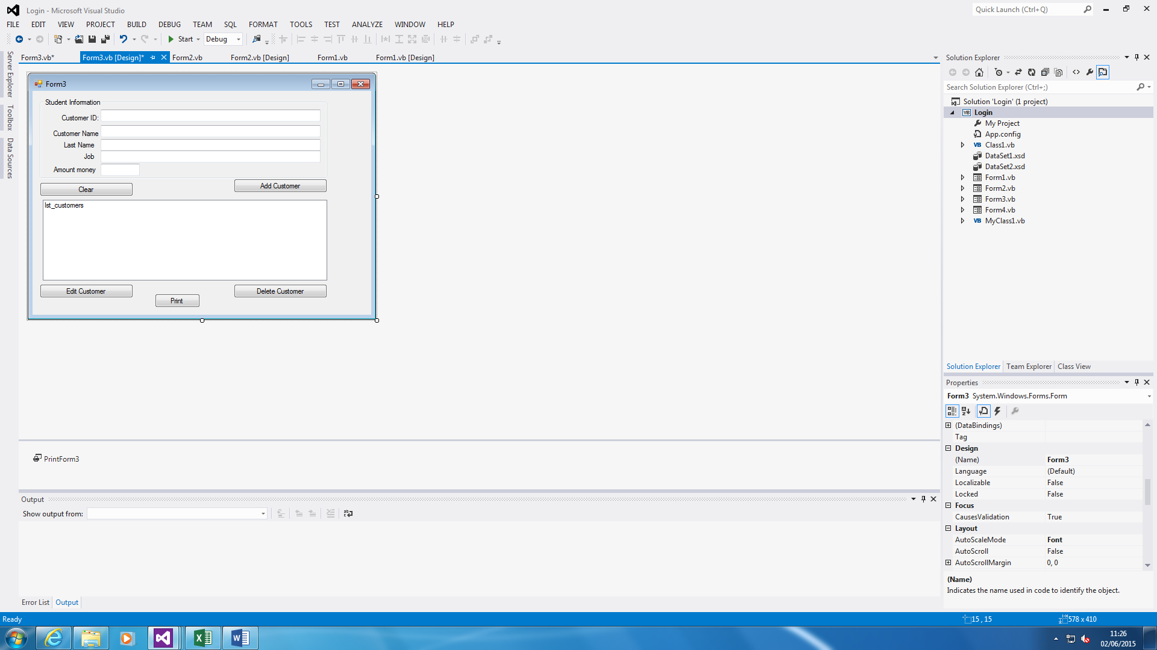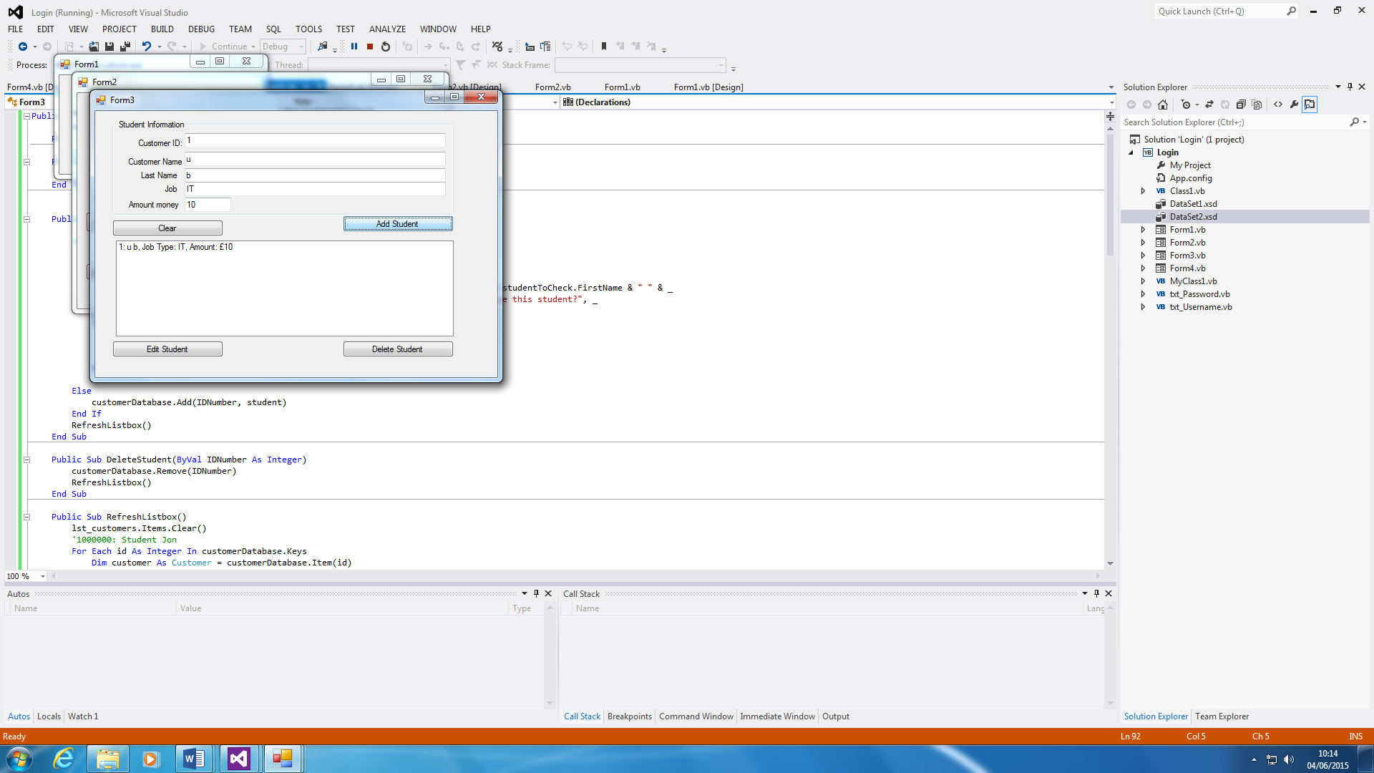

Figure 1.5

**VAT**



Figure 1.6

**Quit Button**

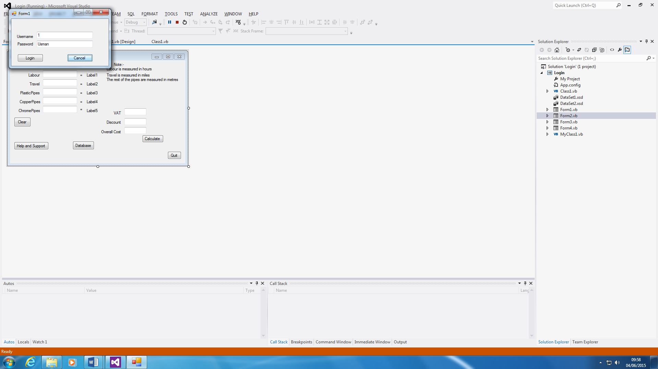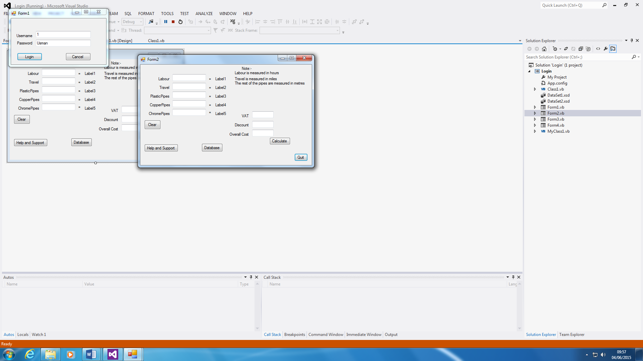

Figure 1.7